Plastics Sales Online

Functional Specifications
Version 1

Prepared by
Last Signal

Contents
DOCUMENT HISTORY 3
PURPOSE 4
SCOPE 4
ASSUMPTIONS 4
OUT OF SCOPE 4
DECISIONS 4
DELIVERABLES 4
APPLICATION 4
1.1 Application Roles 4
1.1.1 Plastics Users 4
1.1.2 Supplier Users 5
1.1.3 Business Admin Users 5
1.1.4 Support Users 5
1.1.5 System Admin Users 5
1.2 Website Layout and Design 5
1.2.1 Login page 5
1.2.2 Registration 6
1.2.3 Home Page 6
1.2.4 Creating Requisition While not logged in 8
1.3 Reports 9
1.4 Glossary 9

DOCUMENT HISTORY

Version | Creation/Revision  Date | Created/Updated by | Comments
1.0 | Jan 17, 2011 | Bahram Daneshgar | Document Creation
1.1 | Jan 23, 2011 | Bahram Daneshgar | Added Product Manager Mockups

PURPOSE
The purpose of this document is to define a system that can be in place in between of the plastic suppliers (manufacturing or reseller) companies and the plastics consumer companies. The Project will help consumers to get quote from different suppliers for the same product. Once consumer users submit a requisition, system will send it to the registered suppliers at the same time. It will then forwards the quotes back to user.

SCOPE
Anything not identified in this document and project plan is out of scope. Out of scope items can be included in the project based on the signed approval of a submitted change order outlining details of the change requested and any impact to original schedule and/or costs.

ASSUMPTIONS
TO BE IDENTIFIED

OUT OF SCOPE
TO BE IDENTIFIED

DECISIONS
TO BE IDENTIFIED

DELIVERABLES
TO BE IDENTIFIED

APPLICATION

Application Roles

Plastics Users
Plastics Users are the major number of users of the application. They are either plastics end users or plastics resellers or distributors. They should be able to do the followings even before logging in:
- To define a custom product
- To add a custom product to the requisition (shopping cart)
They should be able to do the followings once they are logged in:
- To save a custom product with a specific name (part number) for the future use; the name will be unique at the user level.
- To submit a requisition to a specific list of Plastics Suppliers; the list is limited to the registered suppliers in the application and plastics users are able to choose to select between them.
- To place an order by changing a quote to a purchase order

Supplier Users
This group of user is the one who provide plastics. They should be able to do the followings:
- Fulfill and price the requisitions and change them to quotes and submit them to the plastics users
- Get purchase orders

Business Admin Users
This group of user has the highest authority in terms of business administration. They have access to every account of suppliers and plastics users. They are also be able to get business reports.

Support Users
Support Users are the users who sit at the contact center and answer the phone/fax/email from plastics users and supplier users. They are able to create/modify accounts, add logs for the calling customers and escalate issues to the business admin users. They are also able to reset passwords.

System Admin Users
This group of user is the technical users. They have the ability to assign roles, configure system parameter and get the administration reports.

Website Layout and Design

Login page
Login page includes the regular user id and password fields. The same login page is used for different application users.
Login page has a link to reset the password (forgotten password)
There are two different registration links on the login page: supplier’s registration and plastics users’ registration. See Registration
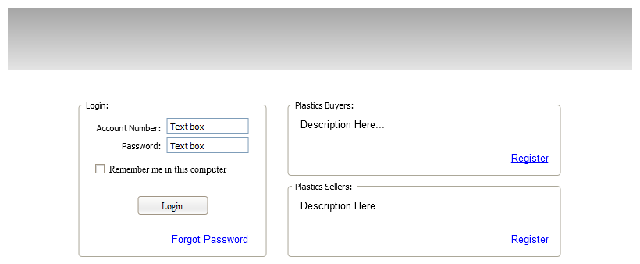

Registration
Plastics users can register themselves using the Plastics Users Registration page. They are also able to ask support to register them over the phone. Supplier users can only be registered by Business Admin Users.
Business users are created by system admin users. (This can be done in the database level and no page is required)
Creating system admin users also can be done in the database level and no page is required.

Home Page
Home page will be different based on the role of authenticated users.

Anonymous Users Home Page
Users are able to do certain things before logging in. Most of these things are getting various information. However, there is one major thing that they should be able to do and it is starting creating a quote. Of course, they should be able to make products to add them to the quote too.

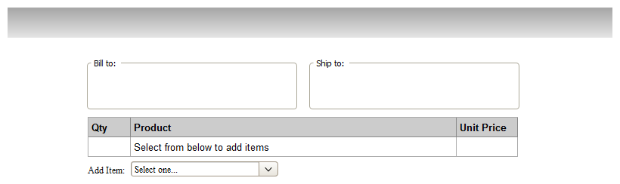
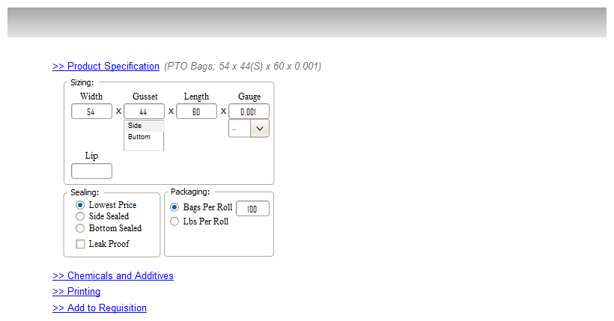
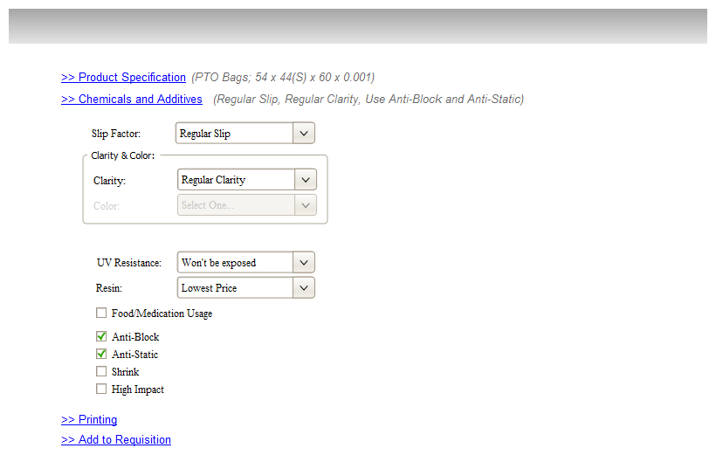
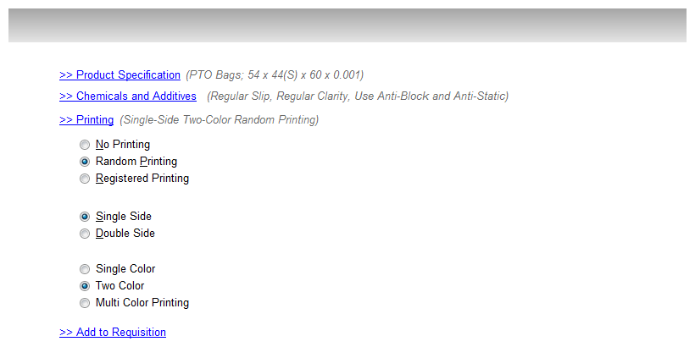
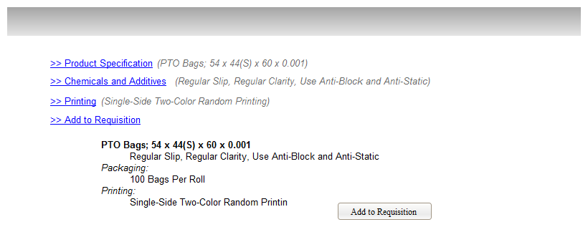

Plastics Users Home Page

Suppliers Users Home Page

Business Admin Users Home Page

System Admin Users Home Page

Creating Requisition While not logged in
Anonymous users should be able to start creating custom product and create a requisition. The system will save the requisition on the server side with a temporary unique id and keep the same id within the client cookie.
The system will remove temporary products, items and requisitions using the application garbage collector.

Reports

Glossary
Requisition
A request for a quote that is submitted by the plastics users
Quote
Order
In this document Order are the same as Purchase Orders
PO
See Purchase Order
Purchase Order
Approved quote by the plastics users. This is the contract document between the end user and the supplier in regards to the purchase.
System Admin User
Business Admin User
Supplier User
Suppliers can be plastic manufacturers or plastics distributors.
Plastics User
End user of the plastics which are the most popular users in the application

Product Maker Module
- Used to make a custom product. Users should be able to make a custom product using this module whether they logged in or not.
- The input and output of this module will be a standard definition of the product and its measures.
- System should be able to save the product to the database, save it to cookie export it to XML or text.
Requisition
- A requisition is a draft document created by user in order to get a quote from suppliers.
- Users make a requisition and send it to the any supplier available in system on their own choice.
- Only logged in users should be able to submit a Requisition
- Once users submit requisition, it will be sent to those suppliers that have been selected by user.

